Paper title

Author 1 (Name, Middle, Surname, Title[s]), Author 2 (Name, Middle, Surname, Title[s])
University1

Author 3 (Name, Middle, Surname, Title[s])
Company2

ABSTRACT

This template illustrates the format that must be used in the preparation of papers submitted to the 4th International Conference on Natural Hazards & Infrastructure. Text and headings should be written in Verdana style. A 16-pt Verdana font will be assigned to the Paper Title with two blank lines left above and one left beneath. The authors’ full names should be written in a 12-pt Verdana font. Exactly beneath the Authors’ Names the Affiliation follows written in an 11-pt Italic font. Authors belonging to the same Institution should appear in the same line. Authors belonging to a different Institution should be separated by a 12-pt line. The contact details of the Corresponding Author should appear as a footnote at bottom of the first page. The abstract should be 250 words or less and should provide a good overview of the paper including an informative summary of the most important results. The abstract should be written in 10-pt font style following a justified alignment. A set of 4 characteristic keywords (written in italic 10-pt style) should be also provided. There is no restriction on the paper length. However, an average length of 8 pages is advised.

Keywords: keyword 1, keyword 2, keyword 3, keyword 4

headings 1

The proceedings of the conference will be compiled directly from the documents received from authors. In order to ensure the best possible overall quality, authors are kindly asked to make every effort to comply with the guidelines outlined herein. The margins should be as specified in this document (A4 paper, 2.0 cm margins on all sides). The Conference Header will appear only in the first page.
The paper should include at least 5 sections: Introduction-Methodology-Results-Conclusions-References. Heading 1 formatting will be applied to all 5 sections. Text should be written using a single line spacing with Verdana 11-pt font. Throughout the paper the text alignment is justified. Do not indent the first line of a paragraph. Paragraphs should be separated by a one-line space.
Heading 1 should be written in bold upper case (Verdana 11-pt font) and be preceded by two (2) and followed by one (1) line space. Heading 2 is written in Verdana bold 11-pt font and should be preceded and followed by one (1) line space. Heading 3 is written in italic Verdana 11-pt font and should be preceded by one (1) line space.

Special Features

Equations
Equations should be aligned centrally and should have a reference number in parentheses at the right side of the page. Equations should be preceded and followed by a one-line space. For example,

[M]{Ü} + [K]{U} = {f(t)} (1)

where [M], [K], {Ü}, and {U} are variables in the equation and should be described in the text. Equations should be referred to in the text as Equation 1, or as Equations 2, 3, and 4.

Figures and Tables
Figures and Tables should be included within the body of the paper. Effort should be made so as figures and Tables be placed close to the text where the reference is made. Each figure should be sequentially numbered and referred to by the respective number in the text, as in Fig.1. Similarly, tables should be referred to as Table 1. All figures and tables must be referred to and described in the text. To assist formatting, authors are advised to place the Figure within a 2-row, 1-column table with no-borders. The figure will cover the top row with central alignment followed by the figure caption within the bottom raw of the table with central alignment also. A one-line space is advised between text-figure.

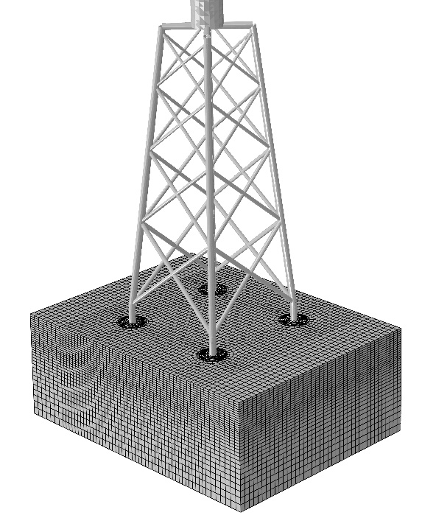
Figure 1. Figure Caption written in 10-pt Verdana text, Italic, centrally aligned

Table captions should be written above the table as in the example that follows. Authors are advised to comply with the provided table format. Leave a one-line space between text and table. Table content should be written in 10-pt Verdana style.

Table 1. Table Caption written in 10-pt Verdana text, Italic, centrally aligned
 | Component1 | Component2 | Component3
Motion1 | Entry11 | Entry21 | Entry31
Motion2 | Entry12 | Entry22 | Entry32
Motion3 | Entry13 | Entry23 | Entry33
Motion4 | Entry14 | Entry24 | Entry34

References
All references must be cited in the text such as (Pecker & Pender, 2000; Atkinson et al, 2018). An alphabetical list of all References in APA referencing style should be included at the end of the paper (after the Conclusions or Acknowledgement section). References will be written in 10-pt Verdana style. The preferred Reference list formatting is displayed below.

CONCLUSIONS

Each paper is expected to concisely describe the conclusions of the work. The Conclusions section should discuss the significance, the applicability and the limitations of the work.

REFERENCES

Atkinson G.M. , D. Wald, C.B. Worden, V. Quitoriano. (2018). The Intensity Signature of Induced Seismicity. Bulletin of the Seismological Society of America, 108(3a), pp. pp. 1080-1086.
Pecker A. & Pender MJ. (2000). Earthquake Resistant Deisgn of Foundations: NEW Construction. GeoEng Conference, (pp. 313-332). Melbourne.

Examples: Christina M. Jones, Ph.D., George G. Werth, AIA, Charles D. Johnson, P.E., M.ASCE, etc.

