Title of your extended abstract

Author 1 (Name, Middle, Surname, Title[s]), Author 2 (Name, Middle, Surname, Title[s])
University1

Author 3 (Name, Middle, Surname, Title[s])
Company2

1 INTRODUCTION & SCOPE OF WORK

The proceedings of the conference will be compiled directly from the documents received from authors. In order to assure the best possible overall quality, authors are kindly asked to make every effort to comply with the guidelines outlined herein. The margins should be as specified in this document (A4 paper, 2.0 cm margins on all sides). The Conference Header will appear only in the first page.
The extended abstract should summarize the key points of the research. It should include a brief introduction on the objectives of the work presented, description of the methodology and major research outcomes.

2 Methodology

The main body should be written in 10-pt Verdana style, and the text should be justified, in terms of alignment.
The abstracts may also include tables, diagrams, graphs, charts, and photos.
One, or, at maximum, two illustrations are preferable. To assist formatting, authors are advised to place the illustration within a 2-row, 1-column table with no-borders. The figure will cover the top row with central alignment followed by the figure caption within the bottom raw of the table with central alignment also. The figure caption should be in 9-pt Verdana, Italic, centrally aligned style. A one-line space is advised between the figure and the text.
All paragraphs are separated by 6pt spacing.
The extended abstract should not exceed 3 pages.

3 RESEARCH OUTCOMES

All references must be cited in the text such as (Tassios, 1998; Anastasopoulos et al, 2017). An alphabetical list of References in APA style should be included at the end of the paper. References will be written in 10-pt Verdana style.
The preferred Reference list formatting is displayed at the end of this template.

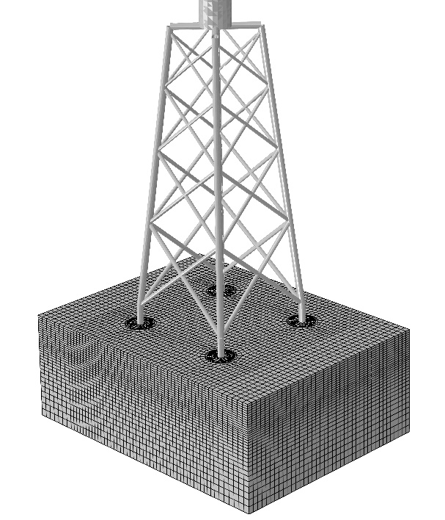
Figure. Figure Caption written in 10-pt Verdana, Italic text, centrally aligned, placed at the bottom of the figure.

Table captions should be written above the table as in the example that follows. Authors are advised to comply with the provided table format. Leave a one-line space between text and table. Table content should be written in 10-pt Verdana style.

Table. Table Caption written in 10-pt Verdana, Italic text, centrally aligned, placed at the top of the table

 | A | B | C | D
A | Aa | Ab | Ac | Ad
B | Ba | Bb | Bc | Bd
C | Ca | Cb | Cc | Cd
D | Da | Db | Dc | Dd
E | Ea | Eb | Ec | Ed

REFERENCES

Anastasopoulos I., G. Gazetas, M. Loli, M. Apostolou, N. Gerolymos. (2010). Soil failure can be used for seismic protection of structures. Bulletin of Earthquake Engineering, pp. 309-326.
Tassios, T. (1998). Seismic Design: State of practice. 11th European Conference on Earthqauke Engineering (pp. 255-267). Rotterdam: AA Balkema.

In case the material presented has been published elsewhere, appropriate reference should be made here. Correspondence to: [corresponding author email]
Examples: Christina M. Jones, Ph.D., George G. Werth, AIA, Charles D. Johnson, P.E., M.ASCE, etc.

